**USER MANUAL**

**FOR**

**MSME SURVEY & SUPPORT MOBILE APPLICATION**

* **Login interface for MSME Survey & Support Mobile Application.**
* **After logging in, the interface will display various features, providing users with easy access to key functionalities.**

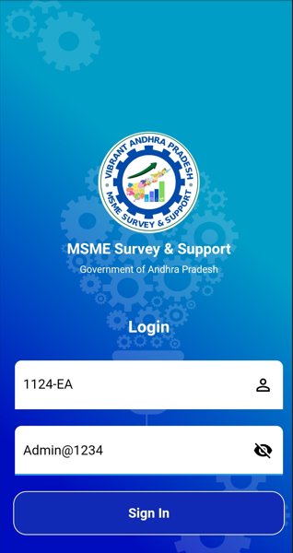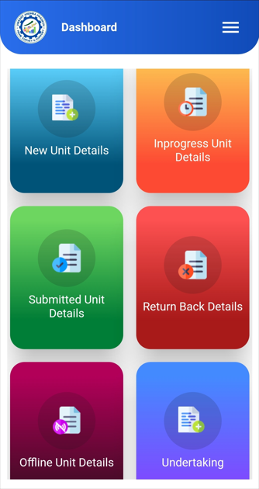

* **The in-progress unit details shows various phases of unit details and final submission.**
* **submitted unit details includes the feasibility of various business which outlines the objectives of the units submitted**

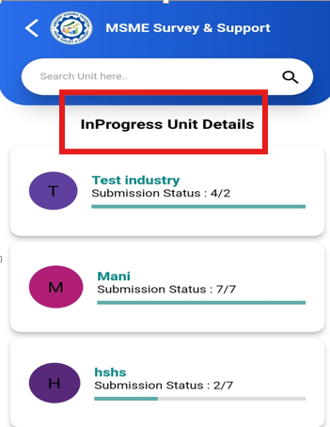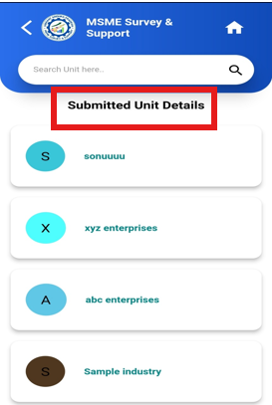

* **after completion of survey enumerator has to submit thw Undertaking which indicated that he has completed the survey of all the MSME enterprises allotted to him/in his supervision**
* The system provides an option to conduct the survey in offline mode when there is no internet access. Once the device reconnects to the internet, the offline data will automatically sync and update as **In Progress** or **Submitted**, based on the survey status

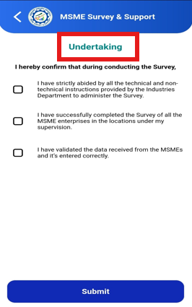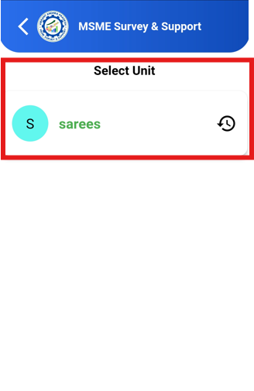

**A.1 Enterprise Details**

**Step 1: Udyam Registration**

Do you have Udyam registration number?

* + Select **Yes** if you have an Udyam Registration Number.
  + Enter the number in the text box provided, and the system will automatically fetch details from the Udyam Portal.if No proceed with further steps

**Step 2**:**Do you have pan card**

* Select yes or no, and proceed with the next steps based on your selection.

**Step 3: Type of Constitution**

Select the type of constitution for your enterprise*.*

* + Choose one option from the following:
    - Sole Proprietorship
    - Hindu Undivided Family
    - Partnership
    - Private Limited Company
    - Public Limited Company
    - Limited Liability Partnership
    - Self Help Group
    - Trust
    - Society

**Step 4: Name of the Enterprise**

Enter the name of your enterprise.

* + enter the enterprise's name in the text box provided.

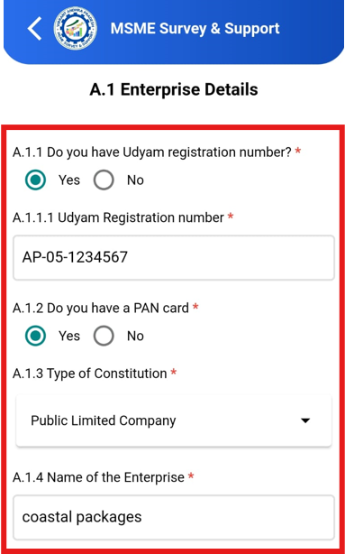

**Step 5: Official Address of Enterprise**

*Enter the office address of the enterprise.*

* + Provide detailed address information as below:
    - Flat/Door/Block No.
    - Name of Premises/Building
    - Village/Town
    - Road/Street/Lane
    - City
    - Pin Code
  + Select the State and District from the dropdown menus.

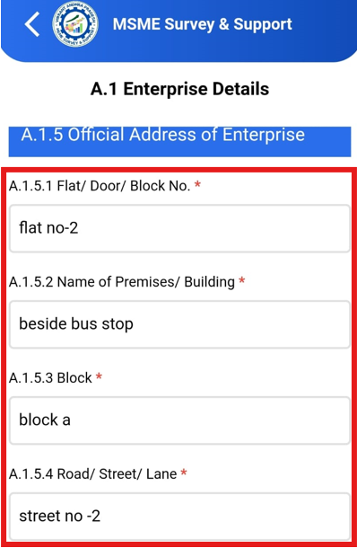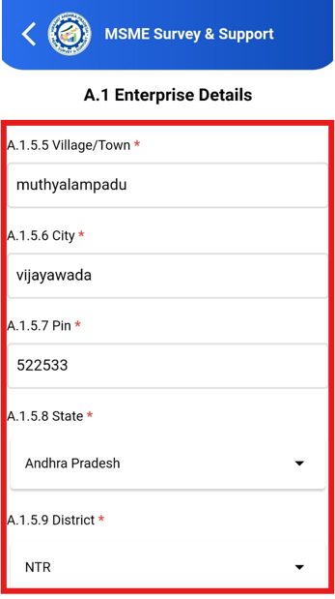

If the office address is the same as the registered address, check the box to auto-fill the details. If it's a different address, uncheck the box and manually enter the registered address.

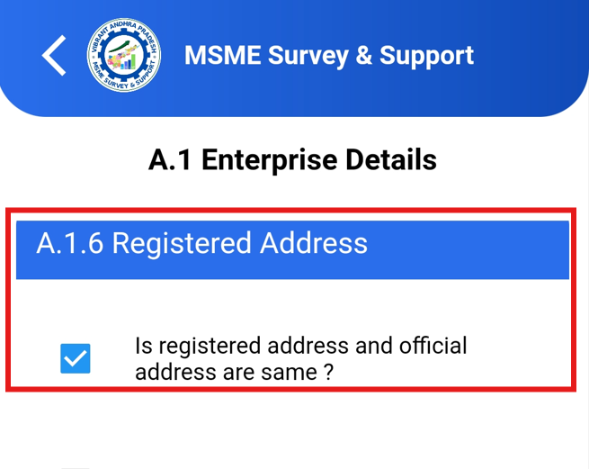 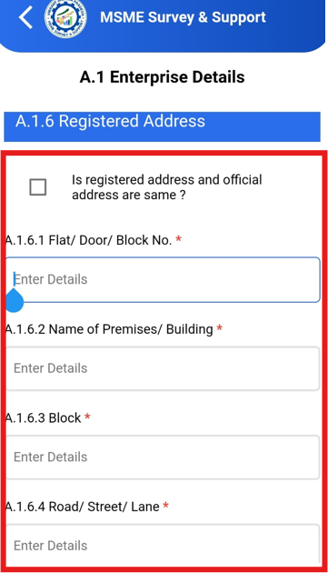

**Step 6: Name of Unit/Plant**

*Enter the name of the unit/plant.*

* + Provide the name of the unit or plant in the text box.
  + Check the box if the unit/plant name is the same as the enterprise name.

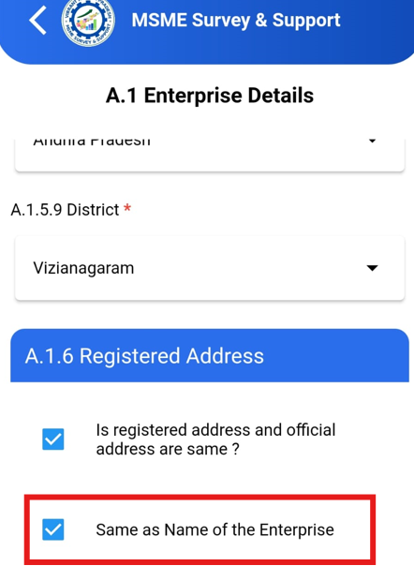 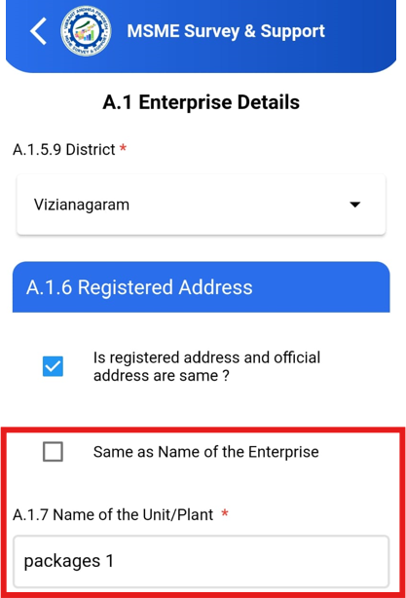

**Step 7: Address of Unit/Plant:**

*Enter the address of the unit/plant.*

* Check the box if the unit address is the same as the official address. If the unit address is different, uncheck the box and manually enter the unit address.

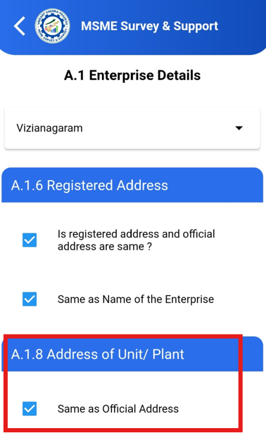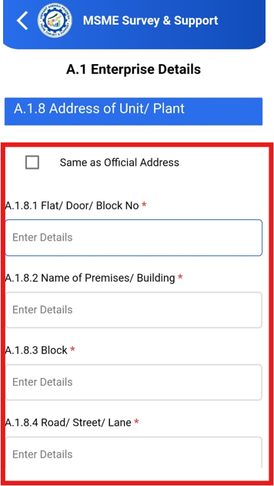

* If the entrepreneur has multiple plants, click on **"Add More"** under the **Add More Plant Details** section and enter the details for each additional plant.

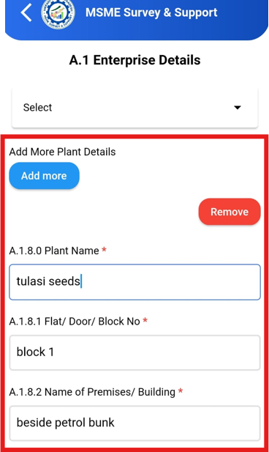

After logging in, the latitude and longitude will be automatically captured based on the location.

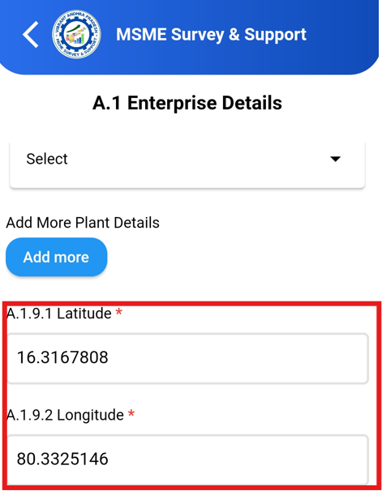

**Step 8: Previous Registration**

*Do you have any previous registration under Entrepreneur Memorandum(EM-II )or Udyog Aadhaar Memorandum(UAM)?*

* + Choose either *NA*, *EM-II*, or *UAM Registration Number*.
  + If EM-II or UAM is selected, enter the registration number in the text box provided.

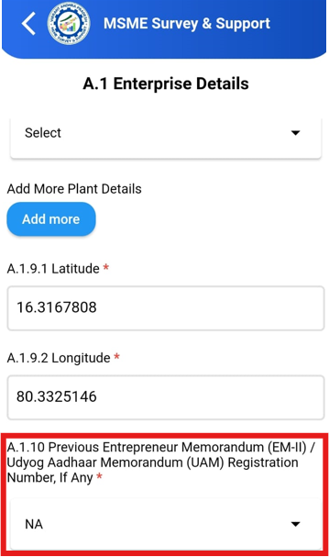

**Step 9: Incorporation and Commencement**

*Enter the date of incorporation.*

* + Select the date from the calendar.

*Whether the production/business commenced?*

Select *Yes* or *No*.

* + If *Yes*, select the date of commencement.

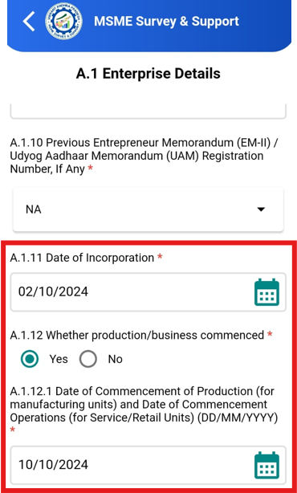

**Note:** An alert will be triggered if the **Date of Commencement** is earlier than the **Date of Incorporation**. The **Date of Commencement** must be equal to or greater than the **Date of Incorporation**.

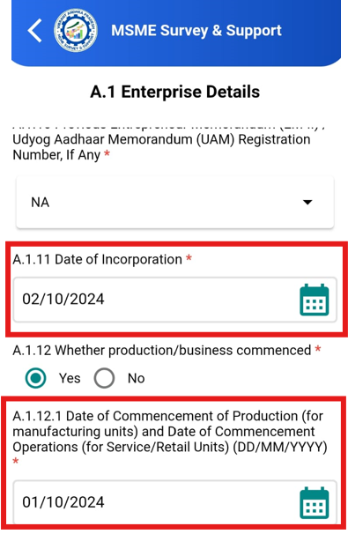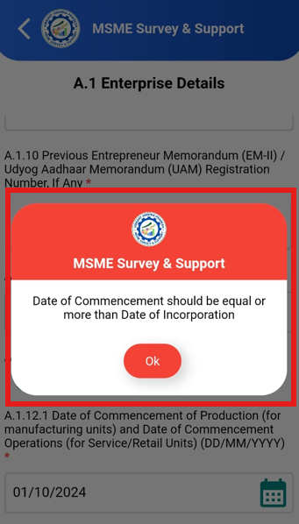

**Step 10: Bank Details (Optional)**

*Enter bank details (optional).*

* + Enter the following:
    - Bank Name
    - IFSC Code
    - Bank Account Number
  + Click **Submit** to complete this section

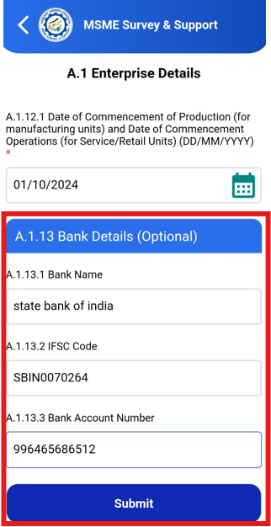

**A.2 Promoter Details**

**Step 1:** Based on the type of constitution selected in section Enterprise Details A.1 enter the required name:

* + Sole Proprietorship → Proprietor
  + Hindu Undivided Family → Karta (Head)
  + Partnership → Managing Partner
  + Private/Public Limited Company → Authorized Signatory
  + Limited Liability Partnership, Self Help Group, Trust, Society → Authorized Signatory

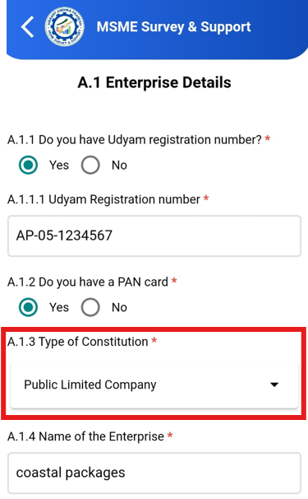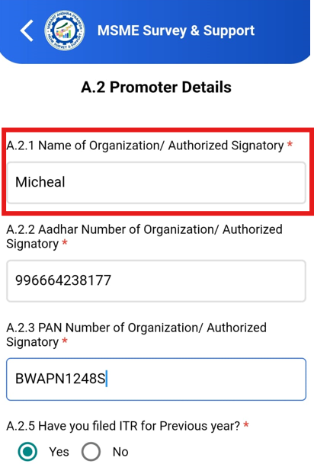

**Step 2:**

• **Aadhar Number:**

* Enter the Aadhar number of the Organization/Authorized Signatory.

• **PAN Number:**

* Input the PAN number for the respective owner or Authorized Signatory.

• **Have you filed ITR for the Previous Year**

* Choose 'Yes' or 'No' from the options.

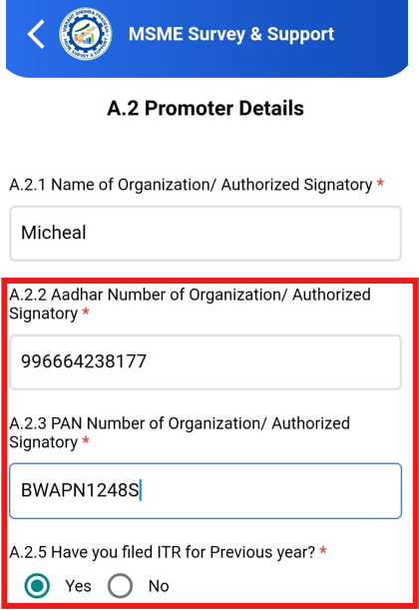

**Step 3: Select Qualification Details**

* If Sole Proprietor, Karta, or Managing Partner, select their highest qualification from the dropdown list.

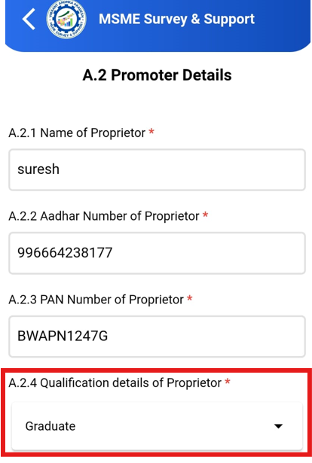

**Step 4: Do you have GSTIN**

* + If yes, enter the GSTIN number, or select **Exempted** if it's not required.

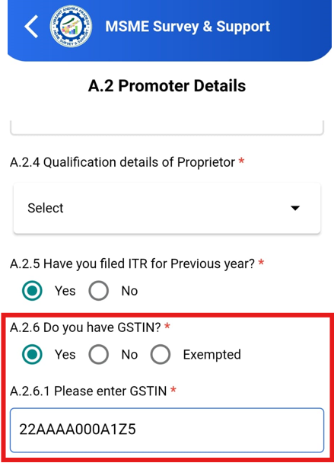

**Step 5: Enter Contact Details**

* **Primary Mobile Number**: Enter the primary contact number of the individual as specified in type of constitution.
* **Alternate Mobile Number**: Enter an alternate number in the additional text box.

**Step 6: Enter Email Address**

* **Primary Email**: Enter the main email address.
* **Alternate Email**: Enter a secondary email address if available.

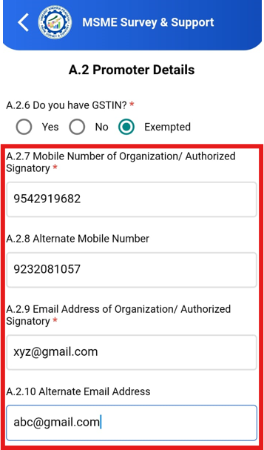

**Step 7: Social Category for major stakeholder**

* Choose the social category from the following:
  + General
  + SC (Scheduled Caste)
  + ST (Scheduled Tribe)
  + OBC (Other Backward Classes)
  + Minorities

**Step 8: Select Gender for major stakeholder**

* Choose the relevant gender from the following:
  + Male
  + Female
  + Others

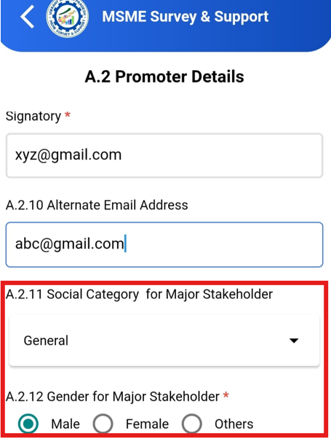

**Step 9: Specially Abled**

* Select 'Yes' if specially abled, otherwise, select 'No.'

**Step 10: Ex-Servicemen/Ex-Servicewomen Status**

* Choose 'Yes' or 'No' if ex-serviceman or ex-servicewoman.

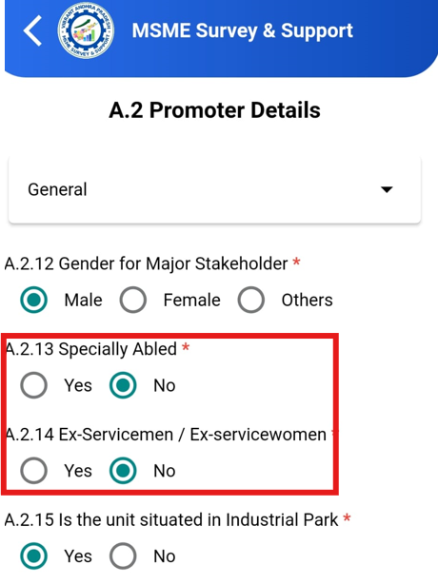

**Step 11: Is the Unit is Located in an Industrial Park (IP)**

* Select 'Yes' if the unit is situated in IP; otherwise, select 'No.'
* If 'Yes', proceed to the next step.

**Step 12: Choose Industrial Park**

* If the unit is located in an IP, choose the IP name from the dropdown list.
* If the industrial park is not listed, there’s an option to add industrial park manually.

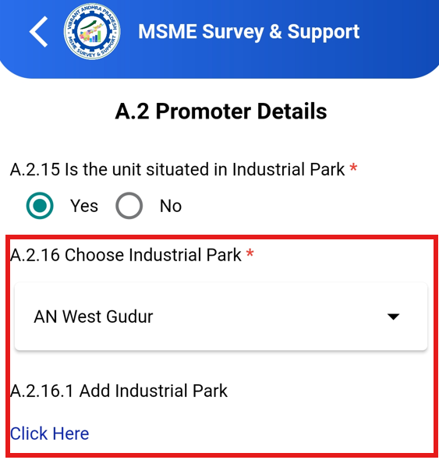 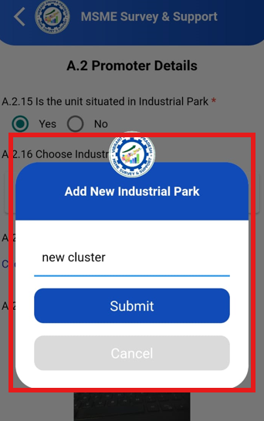

**Step 13: Photo of the Unit**

* take a photo of the unit.

Click **Submit** to complete this section

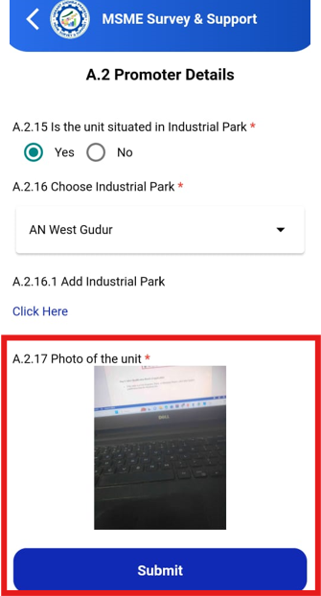

**A.3 Investment & Turnover Details:**

**Step 1: Enter Investment Details**

* Enter the amount of *Investment in Plant and Machinery or Equipment* field, in Rupees (Rs.).
* In the *Investment on Land* enter the amount in Rs.
* In the *Investment on Building* enter the amount in Rs.

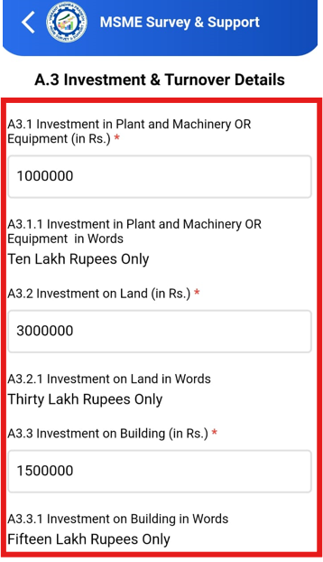

**Step 2: Turnover for the Last Financial Year**

* In the *Total Turnover* field, enter the total revenue generated in Rs.
* In the *Turnover for Exports* field, enter the turnover specifically from exports.

Once both values are entered, the system will automatically calculate and display the *Net Turnover* (Total Turnover minus Exports).

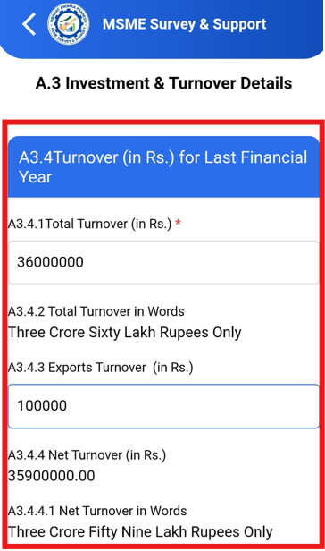

**Step 3: Category of Industry**

* Based on the values entered for investment and turnover, the *Category of Industry* will be auto-populated. The possible categories are:
  + **Micro**: Investment up to Rs. 1 crore, turnover up to Rs. 5 crore
  + **Small**: Investment up to Rs. 10 crore, turnover up to Rs. 50 crore
  + **Medium**: Investment up to Rs. 50 crore, turnover up to Rs. 250 crore

This field is auto-calculated; you only need to verify the displayed category.

Click **Submit** to complete this section

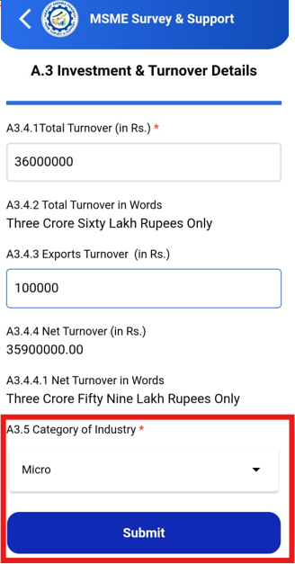

**A.4 Product/Service Details:**

#### Step 1: Enter Major Activity of Unit

* Select the **major activity** of the unit, is **Manufacturing** or **Services**.
* If you choose **Services**, proceed to the next step to provide more details.

#### Step 2: Select Major Activity under Services

* If selected **Services**, choose from **Trading** or **Non-Trading** activities.

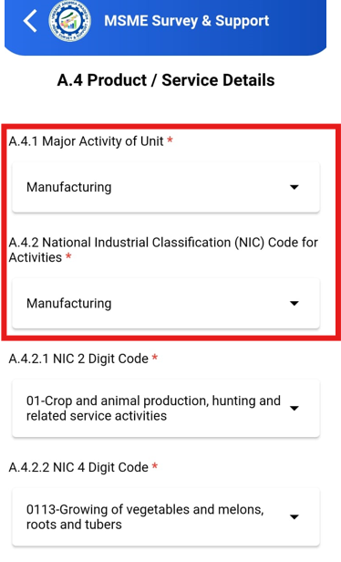

#### Step 3: Choose NIC Code

* Select the **NIC 2 Digit Code** from the dropdown list. The available options will be based on the activity you selected in the previous step.
* After selecting the 2-digit code, proceed to choose the **NIC 4 Digit Code** and **NIC 5 Digit Code** from the dropdown lists.
* You can add the other line of activity in the text box.

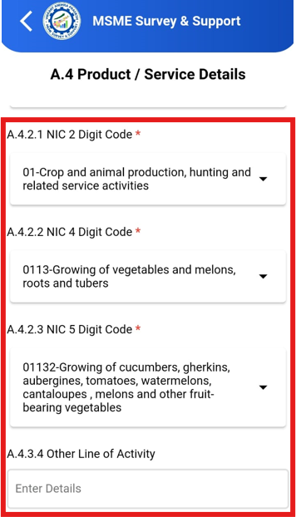

#### Step 4: Number of Persons Employed

* enter the number of employees under the following categories:
  + **Male**
  + **Female**
  + **Other Social Category**
* The total number of employees will be calculated automatically.
* Click **SUBMIT** to complete this section.

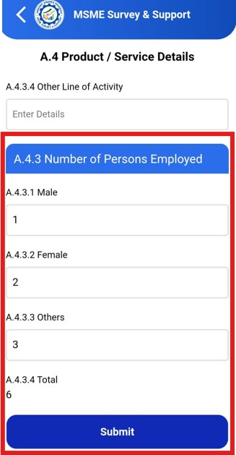

**A.5. Consent for Udyam Registration:**

**Step 1: Select District Industries Centre (DIC)**

* From the dropdown menu, select the appropriate **District Industries Centre (DIC)** where the business is operating.

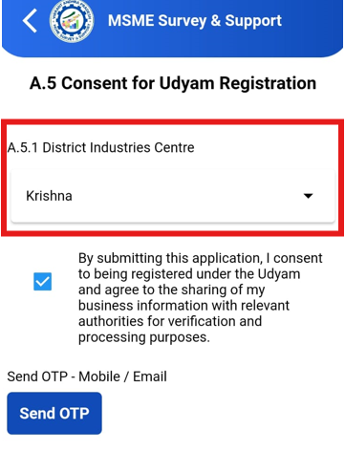

**Step 2: Trigger OTP for Verification**

* After selecting the DIC, an **One-Time Password (OTP)** will sent to both your registered **mobile number** and **email address**.
* Enter the OTP in the respective text box to verify your contact details.

**Step 3: OTP Verification Consent**

* Before submitting the OTP, ensure that you read and acknowledge the consent message that appears:

“By submitting this application, I consent to being registered under the Udyam and agree to share my business information with relevant authorities for verification and processing purposes.”

* Enter the OTP in the text box.

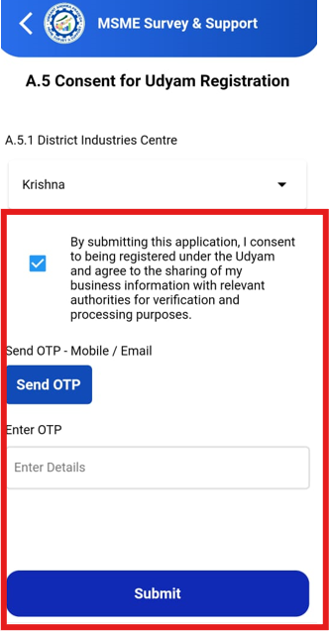

**B.1 Formalisation**

#### ****Step 1: Select Land Details and Expansion Plans****

In this step, select the type of land of the unit by choosing from the available options (Own, Lease, Rented, APIIC, or Govt Land). Choose whether you have plans for future expansion by selecting **Yes** or **No**. If select **Yes**, specify whether you need **Land** or **Flatted Factory Complex (FFC)**, and enter the required area and location details

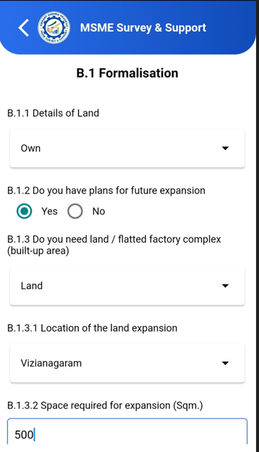

#### ****Step 2: Trade License and Labour Identification Number (LIN)****

1. Here **"Do you have a Trade License Number?"**
   * Select **Yes** or **No**.
   * If **Yes**, enter the **Trade License Number** in the text box.
2. Here **"Do you have a Labour Identification Number?"**
   * Select **Yes** or **No**.
   * If **Yes**, enter the **Labour Identification Number (LIN)**

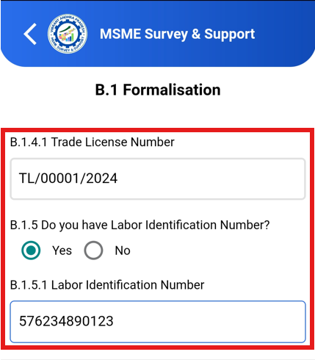

#### ****Step 3: Factory License (For Manufacturing Units Only)****

1. If the business type is **Manufacturing**, then this question will come
   * Select **Yes** or **No**.
   * If **Yes**, enter the **Factory License Number**.

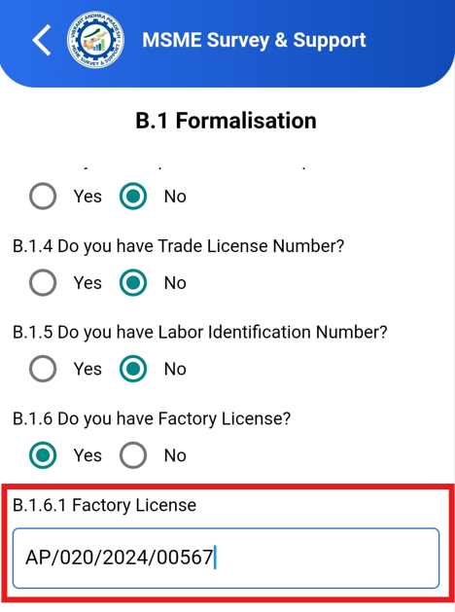

#### ****Step 4: Enter Power Connection Details****

1. Enter **Electric Service Connection Number**.
2. Select the **load capacity** in KW, KVA, or HP.
3. Enter the **total connection power load**.
4. Enter the **power consumption units** for the previous month.
5. Click **Submit** to complete this section.

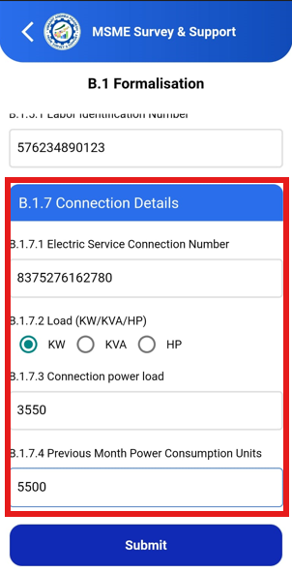

**B.2 Sector Wise**

#### ****Step 1: Raw Material Data****

1. For **Raw Material**, enter count of raw materials for the sector.
2. For each raw material, enter the following:
   * **Name**: Specify the name of the raw materials.
   * **Quantity**: Specify the amount
   * **Unit**: Select the appropriate unit from the dropdown (Kilograms, Metric Tons, etc.).
   * **Source of raw material imports**:
     + Enter the percentage, sourced locally within Andhra Pradesh.
     + Select **India (State-wise)**, enter the state of sourcing and its percentage.
     + Select **Country**, choose the country of import and its percentage.

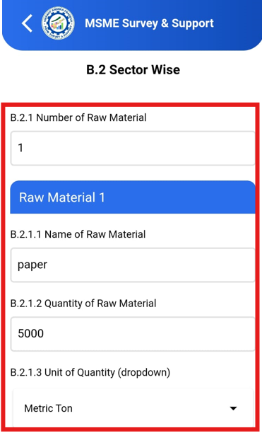 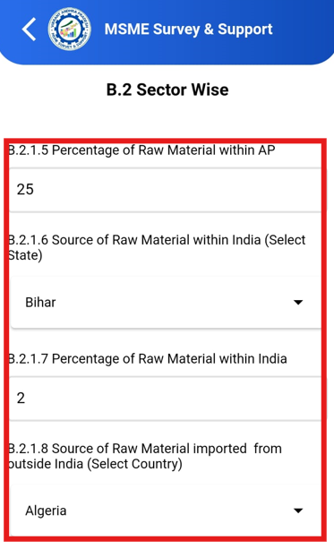 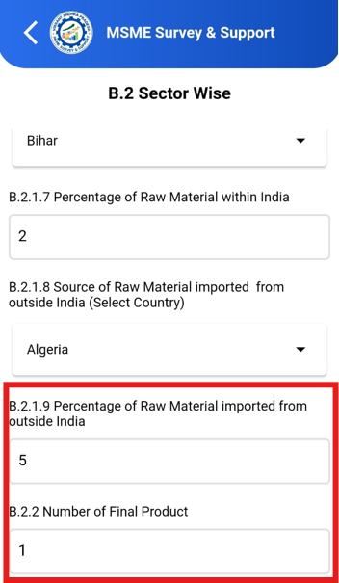

#### ****Step 2: Final Product Data****

1. For **Final Product**, enter the count of final products for the sector.
2. For each product, enter the following:
   * **Name**: Specify the name of the final product.
   * **Quantity**: Specify the amount produced.
   * **Unit**: Select the appropriate unit from the dropdown.
   * **Exports Source**:
     + Enter the percentage, exported locally within Andhra Pradesh.
     + Select **India (State-wise)** and enter the state of export and the percentage.
     + Select **Country** and choose the country of export and its percentage

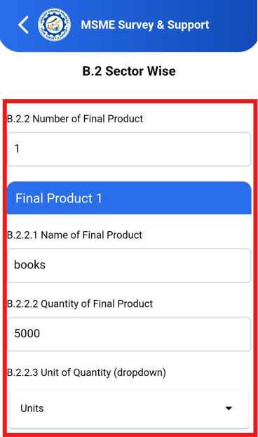 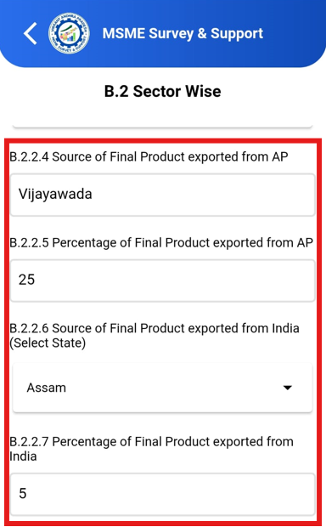 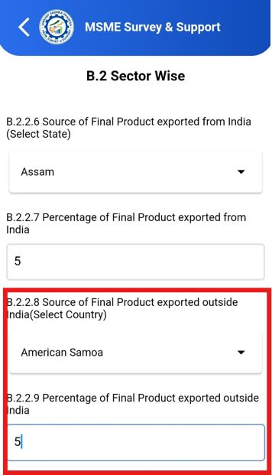

**Step 3**: Also have the option to upload a **PDF** file containing your product range and certification details.

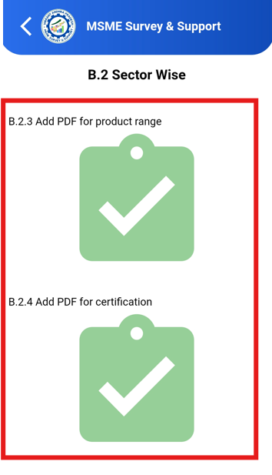

#### ****Step 4: Quality Certifications****

1. In the **Quality Certifications** section, select whether your business has any certifications:
   * If **Yes**, provide the **Name of Certification** and **Year of Certification** from the dropdown list.
   * Click **Add More** if you have multiple certifications and specify.
2. Once all information is provided, click **Submit** to finish this section.

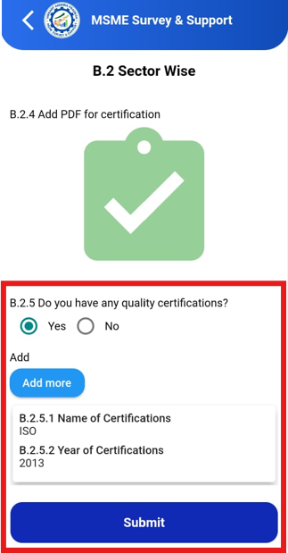

**B.3 Others**

#### ****Step 1: Location in a Cluster****

1. Here **"Are you located in a cluster?"**, select **Yes** or **No**.
   * If **yes**, choose the relevant cluster from the dropdown list.
   * If your cluster is not listed, select **others** and enter the cluster name in the text box.

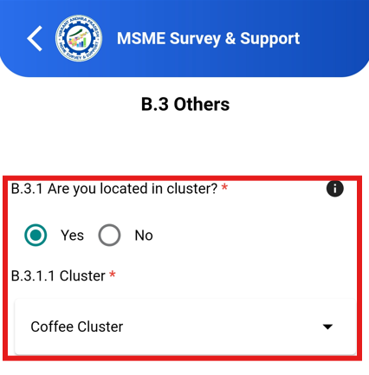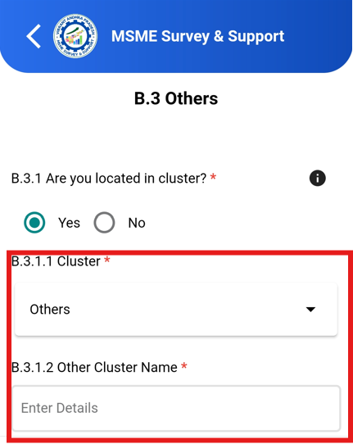

#### ****Step 2: Infrastructure Requirements****

1. In the **"Infrastructure requirement in the cluster" section**, select the relevant infrastructure needs by checking the appropriate options from the drop down list. If your infrastructure requirement is not listed. Select **others** and mention in the text box.

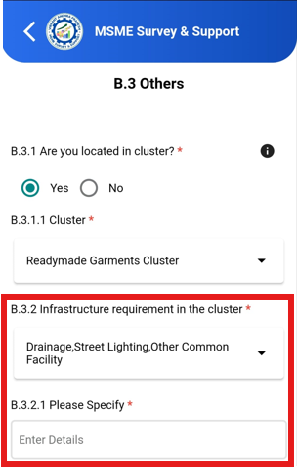

#### ****Step 3: Challenges in Doing Business****

Here **"What are the challenges faced by you in doing business?"**, select your **top 3 challenges** from the drop down list. If you’re facing challenges are not listed. Select **others** and mention the challenges in the text box.

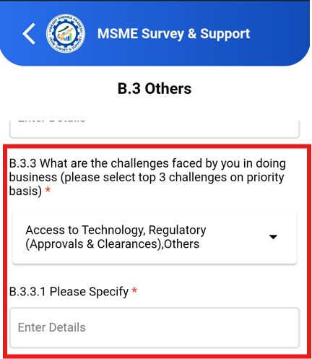 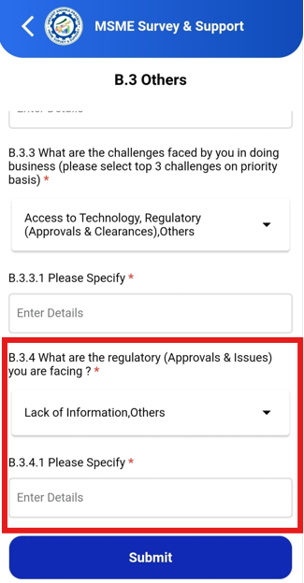

**C. Credit Assistance Details**

#### ****Source of Funding****

1. In the, **"Source of Funding" section**, select Equity, Debt or both:
   * **Equity** and/or **Debt**
2. If you select **Equity**, enter the percentage of equity in the text box.
3. If you select **Debt**, enter the percentage of debt in the text box.

**Note:** An alert will triggered if the combined value of Equity and Debt is not equal to 100%, or if either Equity or Debt individually exceeds 100%.

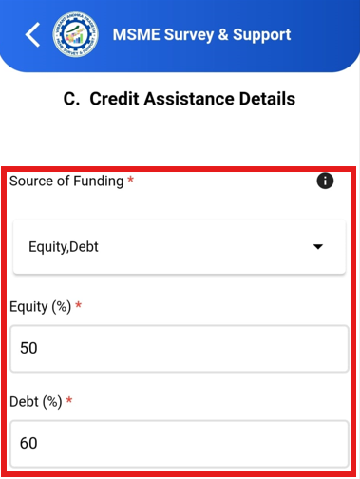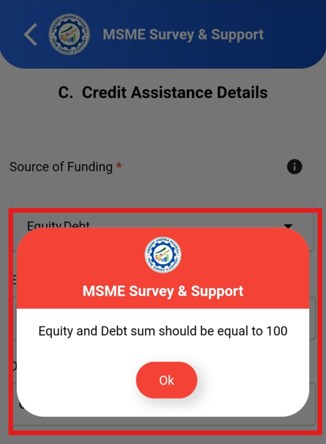

#### ****Step 2: Source of Term Loan****

1. In the **"Source of Term Loan" section**, select one or more sources from the following:
   * **Self**
   * **Banks**
   * **NBFC (Non-Banking Financial Companies)**
   * **Private Lenders**
   * **Others**
2. If you select **Banks** or **NBFC**, enter the **name of the Bank/NBFC** in the text box.
3. If you select **Others**, provide details in the text box.

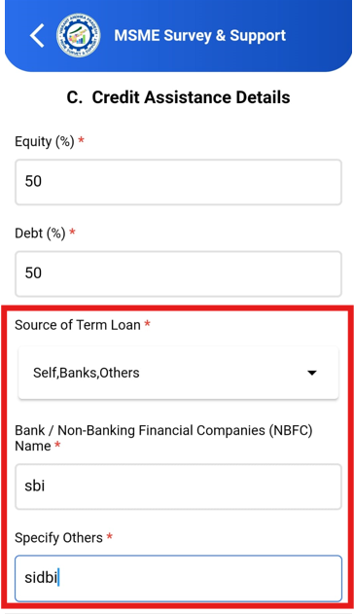

#### ****Step 3: Loan Approval Status****

1. Here **"Did you get the full loan amount that you applied for?"**, select one of the following:
   * **Partial Loan**
   * **Complete Loan**
   * **Loan Rejected**
2. If you select **Loan Rejected**, please select the rejection reason:
   * Lack of Collateral Security
   * Project Not Viable
   * Low CIBIL Score of the Promoter
   * Other (enter details in the text box)
3. If you select **Partial Loan**, proceed to next

#### ****Step 4: Percentage of Partial Loan**** (For Partial Loan Applicants Only)

1. Enter the **percentage of the loan** received out of your total investment

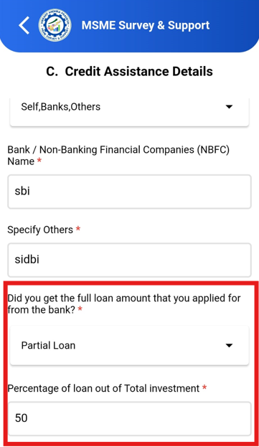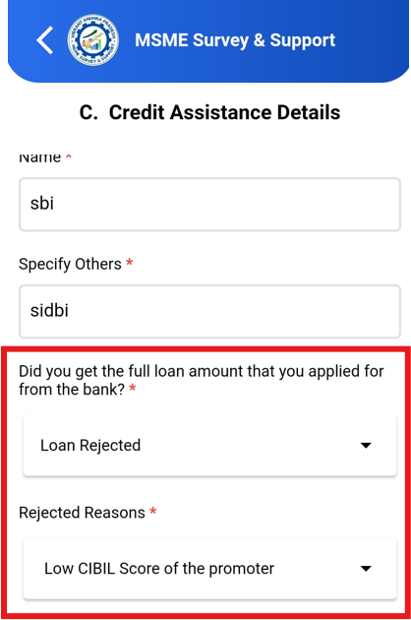

#### ****Step 5: Managing the Remaining Amount**** (For Partial Loan Applicants Only)

1. Here **"How did you manage the remaining amount?"**, select one of the following:
   * **Self-Finance**
   * **Borrowed from Private Lender**
   * 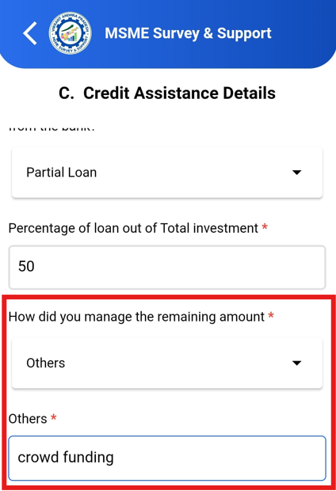**Others** (provide details if applicable)

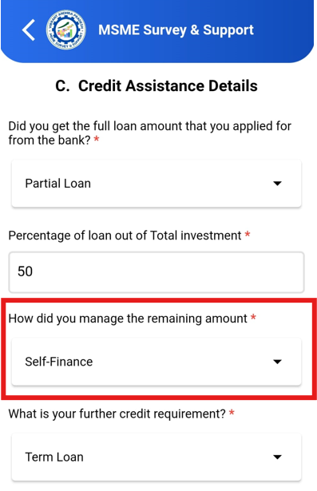

#### ****Step 6: Further Credit Requirements****

1. Here **"What is your further credit requirement?"**, select one or more options from the following:
   * **Term Loan**
   * **Working Capital**
   * **Both**

#### ****Step 7: Specify Term Loan or Working Capital Amount****

1. If you selected **Term Loan** or **Working Capital**, specify the required amount:
   * **No further credit requirements**
   * **Up to INR 5 lakhs**
   * **> INR 5 lakhs up to INR 25 lakhs**
   * **> INR 25 lakhs up to INR 50 lakhs**
   * **> INR 50 lakhs up to INR 1 crore**
   * **> INR 1 crore**

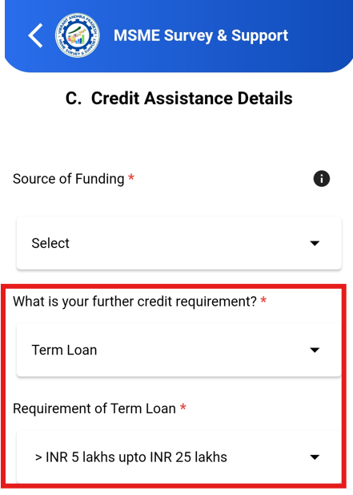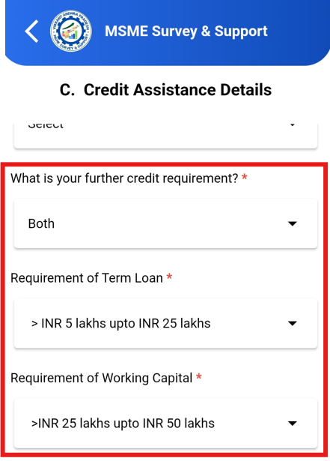

#### ****Step 8: TReDS Registration****

1. Here **"Are you registered with TReDS?"**, select **Yes** or **No**.
   * If select **No**, question will trigger, **"Do you want to register?"** Select **Yes** or **No**.

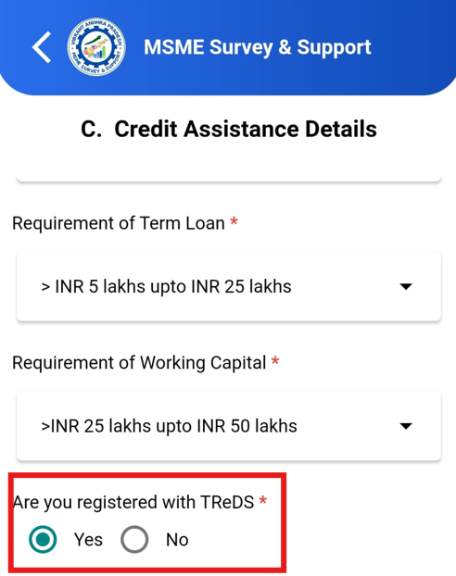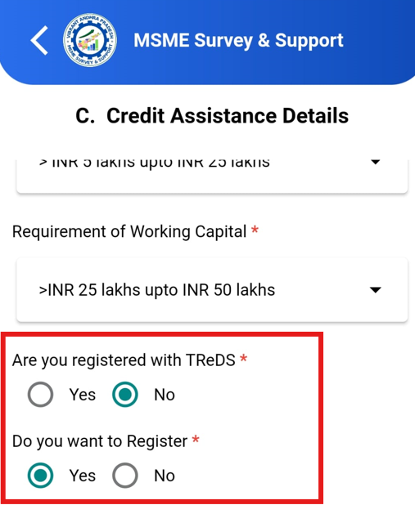

#### ****Step 9: Incentives from State/Centre****

1. Here **"Have you availed any incentives from State/Centre?"**, select **Yes** or **No**.
   * If **Yes**, proceed to the next step

#### ****Step 10: Central Incentives Availed****

1. In the **"Central Incentives Availed"** section, select the applicable incentives from the following:
   * **PMEGP**
   * **CGTMSE**
   * **CHAMPIONS (ZED, LEAN, IPR)**
   * **Schemes for Women Entrepreneurs**
   * **Others** (enter details if applicable)

#### ****Step 11: State Incentives Availed****

1. In the **"State Incentives Availed"** section, select the applicable incentives from the following:
   * **IDP**
   * **IIPP-2005-10**
   * **Others** (provide details in the text box if applicable)

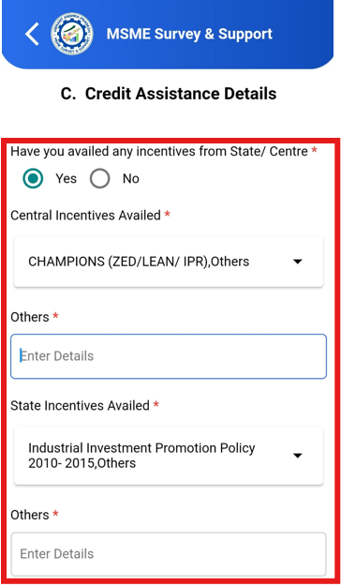

#### ****Step 12: Awareness of Central Government Schemes****

1. Here **"Are you aware of Central Government Schemes for MSMEs?"**, select all relevant schemes from the dropdown list .
2. Click **Submit** to complete this section

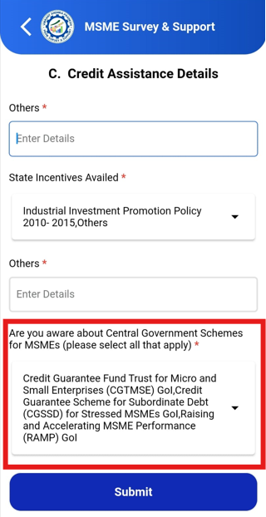

**D. Employment and Human Resources:**

#### ****Step 1: Enter Existing Employees****

1. In the **"Existing Employees"** section, enter the number of employees for each category:
   * **Permanent**
   * **Contractual**
   * **Temporary/Casual**
   * **Seasonal**
2. Enter the number of employees based on gender (Male, Female, Other) for each category.
3. The **"Total"** column count will auto-generate based on the inputs.

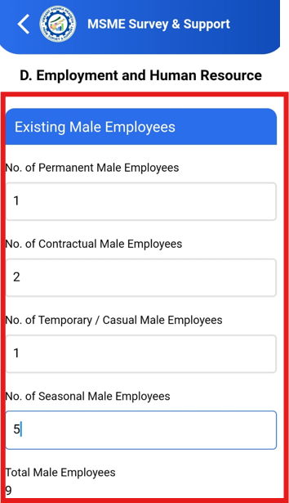 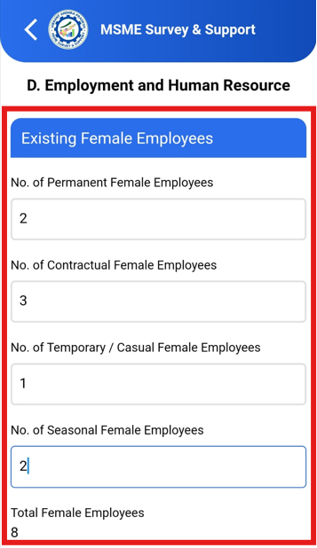

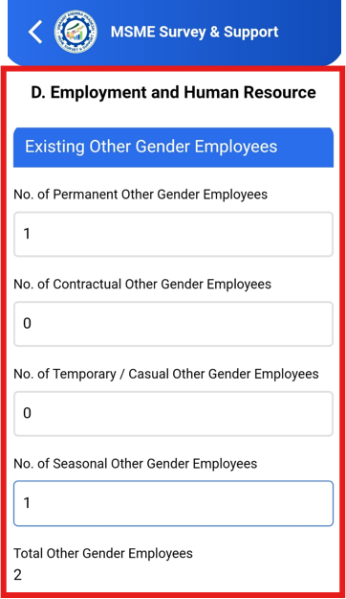 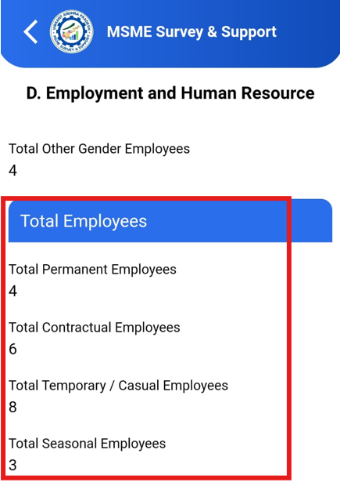

#### ****Step 2: Employees by Skill Level****

1. In the **"Employees by Skill Level"** section, enter the number of employees for each skill level:
   * **Unskilled**
   * **Semi-Skilled**
   * **Skilled**
   * **Highly Skilled/Technical**
   * **Managerial/Administrative**
2. Enter the number of employees for each skill level by gender (Male, Female, Other).
3. The **"Total"** column count will auto-generate based on the inputs.

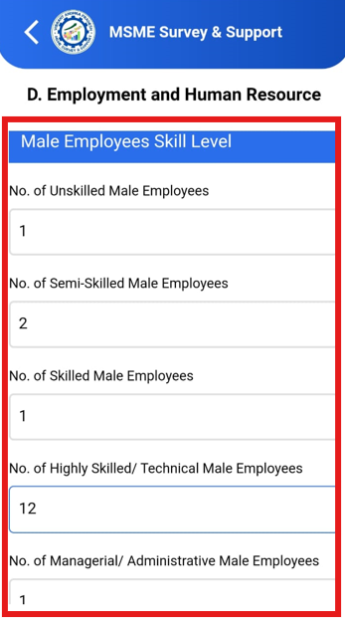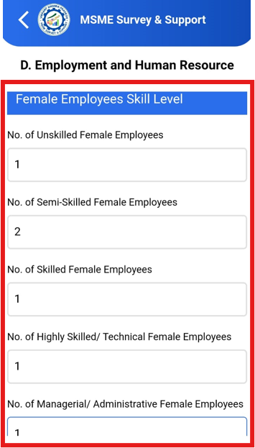

#### ****Step 3: Required Skill Sets****

1. In the **"Required Skill Sets"** section, enter the following details for each occupation:
   * **Positions – Existing**: Specify the number of employees required for Manager, Support, and P&M Operators.
   * **Positions – Anticipated**: Specify the anticipated number of employees for Manager, Support, and P&M Operators.
   * **Minimum Education**: Enter the required education level.
   * **Minimum Experience**: Enter the required years of experience.
   * **Budgeted Salary**: Enter the budgeted salary range.
   * **Certification**: Specify any certifications required.

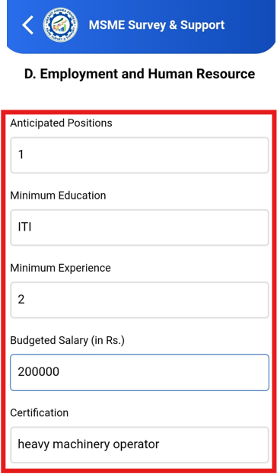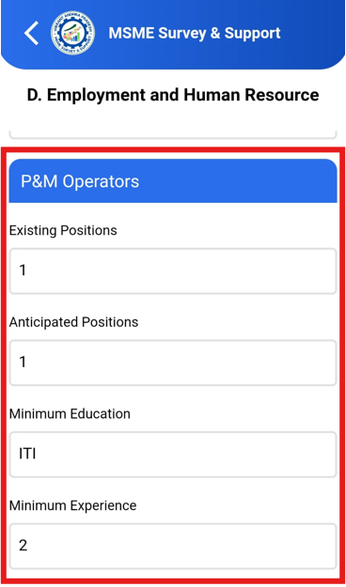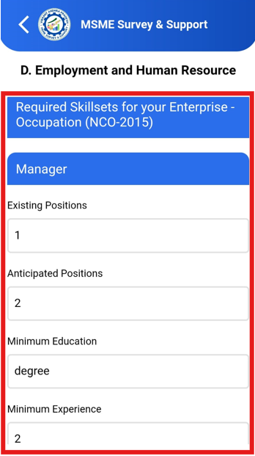 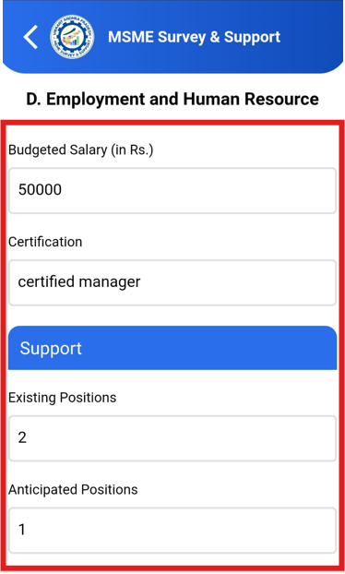 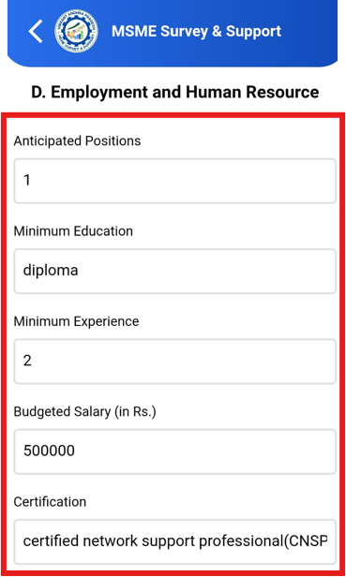

#### ****Step 4: Training Support****

1. Here **"Do you need any training support?"** section, select **Yes** or **No**.
   * If **Yes**, fill the following details:
     + **Type of Training**: Choose **Online**, **Classroom**, **Apprenticeship**, etc.
     + **Duration**: Specify the duration (Months/Weeks/Days).
     + **Mode of Training**: Select **Online** or **Offline**.

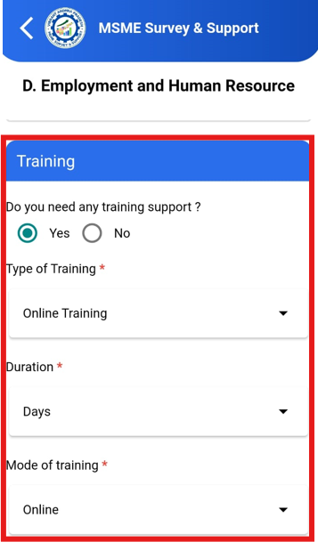

#### ****Step 5: Preferred Source of Hiring****

1. In the **"Preferred Source of Hiring"** section, select one or more sources for hiring:
   * **Relatives**
   * **Local Community**
   * **Online Platforms**
   * **Recruitment Agencies**
2. If you select **Others**, enter details in the text box.

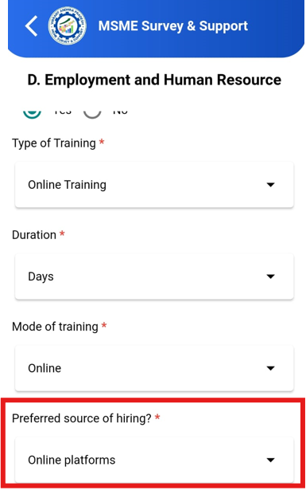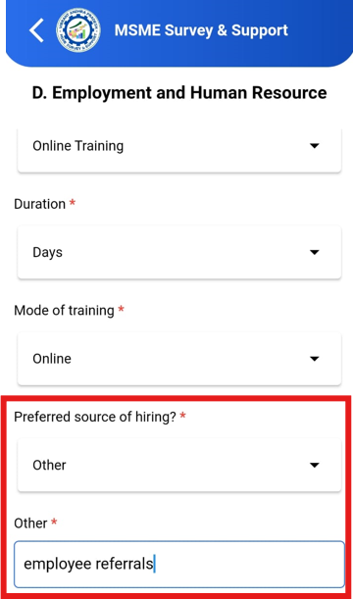

#### ****Step 6: Willingness to Hire under Various Schemes****

1. Here **"Are you willing to hire under"** section, select **Yes** or **No** for each of the following questions:
   * **National Apprenticeship Promotion Scheme (NAPS)**
   * **Practical Training**
   * **AP Skill Development Council / GoAP**
   * **Employment Directorate**
2. Click **Submit** to complete this section.

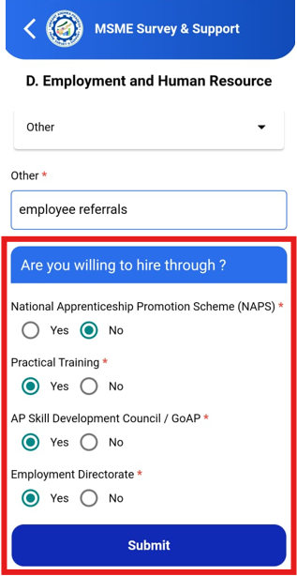

**E. Marketing Details**

**Step 1: Registration with E-Commerce or ONDC**

1. Here **"Are you registered with e-commerce platform or ONDC?"** section, select one of the following options:
   * **E-commerce**
   * **ONDC**
   * **None**
2. If select **E-commerce**, enter the e-commerce platform in the provided text box.
3. If select **None**, proceed to **Step 2.**

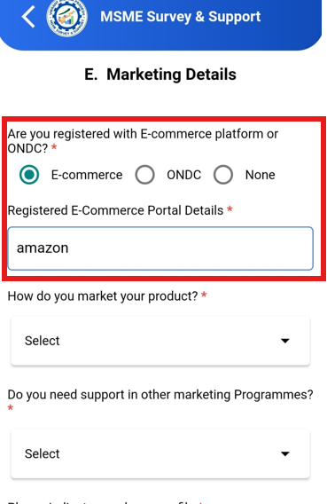

#### ****Step 2:**** **"Are you willing to register on e-commerce platforms or ONDC?"** section, select one of the following options:

* + **E-commerce**
  + **ONDC**

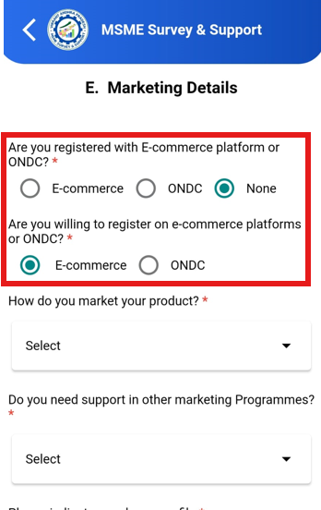

#### ****Step 3:**"**How do you market your product**?"** section, select from below dropdown list:

* + **Agents**
  + **Own Distributors**
  + **GEM(Government E Market place)**
  + **Government**

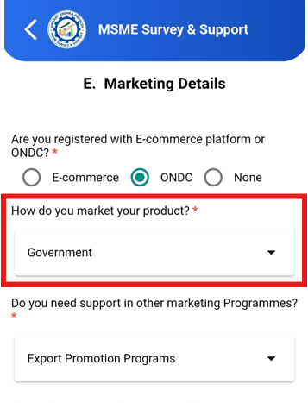

#### ****Step 4: Support in Marketing Programs****

1. Here **"Do you need support in other marketing programs?"** section, select any applicable options:
   * **PMS(Procurement & Marketing Support)**
   * **Export Promotion Programs**
   * **Others** (specify in the provided text box)

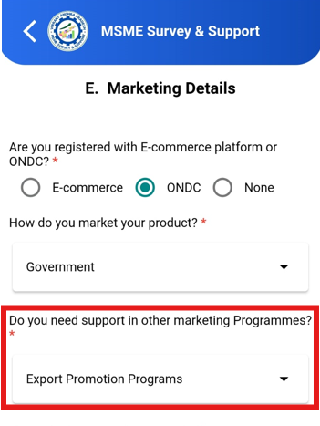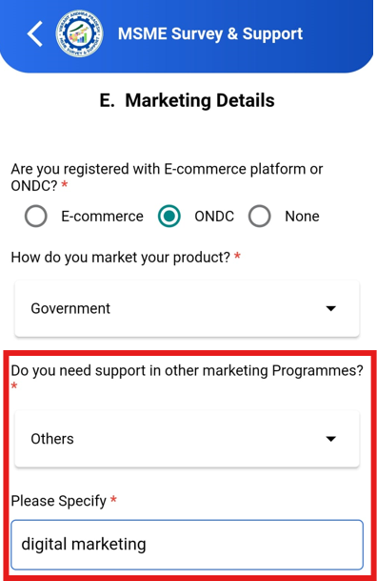

#### ****Step 4: Buyer Profile & Government Schemes****

1. In the **"Please indicate your buyer profile"** section, select one or more options:
   * **Retailers**
   * **Wholesalers**
   * **Government PSUs at Central and State Level**
   * **Online Buyers**
   * **Others** (please specify in the text box)
2. Next, Here **"Have you availed marketing support under any Central/State Government scheme?"**, select:
   * **Yes** or **No**
3. If **Yes**, specify the name of the scheme(s) in the text box.

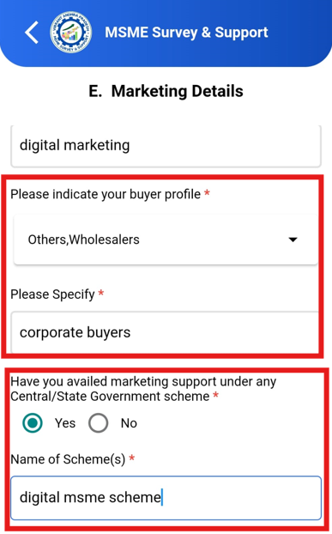

#### ****Step 5:** "What supply chain disruptions are you facing?"** section, select one or more options:

* + **Raw Material Procurement**
  + **Logistic Challenges**
  + **Plant and Machinery Maintenance and Spare Parts**
  + **Workforce**

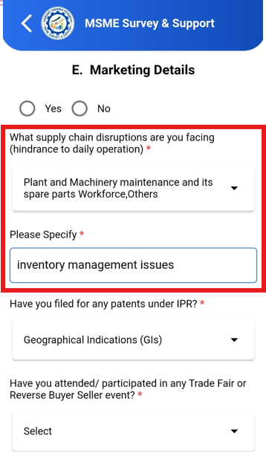

#### ****Step 6: Intellectual Property Rights (IPR)****

1. In the **"Have you filed for any patents under IPR?"** section, select Yes or No if yes select from dropdown list:
   * If any other, please specify in the text box.

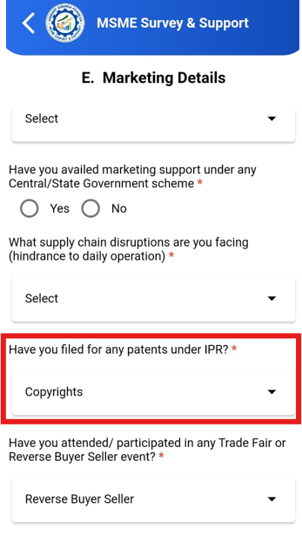

#### ****Step 7: Participation in Trade Events****

1. Here **"Have you attended/participated in any Trade Fair or Reverse Buyer Seller event?"** section, select one of the following:
   * **Trade Fair**
   * **Reverse Buyer Seller**
   * **Both**
   * **None**
2. If you select **None**, proceed to **Step 8**.



#### ****Step 8: Interest in Future Events****

1. Here **"Would you like to attend?"**, select any options you are interested in:
   * **Trade Fair**
   * **Reverse Buyer Seller**
   * **Both**
2. Click **Submit** to complete this section.

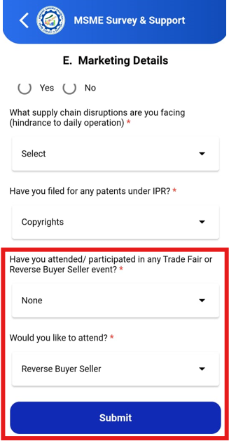

# **MSME Survey App - Settings Menu**

Settings Menu in the MSME Survey app. Detailed information about each feature

### 1. **Sync Latest Data**

* **Description**: This option allows users to synchronize the latest data.
* **How to Use**:
  1. Tap the **Sync Latest Data** button.
  2. Wait for the sync process to complete. A pop up will come once data is synced.

**FAQs**:

* **Description**: Provides answers to common queries about using the app.
* **How to Use**: Tap the FAQs button to access a list of common questions. Scroll through to find relevant answers.

**Change Password**:

* **Description**: Enables users to update their password for enhanced security.
* **How to Use**: Tap the **Change Password** option, enter your current password, then enter and confirm your new password. Tap **Submit** to save.

**Theme Customization**:

* **Description**: Switch between light or dark mode for the app’s interface.
* **How to Use**: Tap the **Theme** option, then choose your preferred mode (e.g., Light or Dark).

**Logout**:

* **Description**: Securely logs the user out of the app.
* **How to Use**: Tap the **Logout** button, and confirm the logout action.

