Conversion of White Card to Pink Card C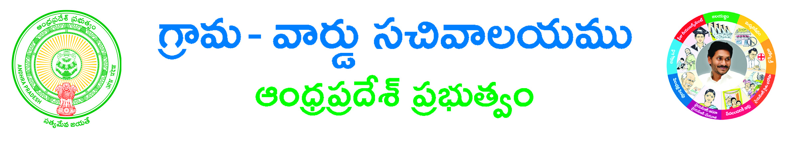onversion of White Card to Pink Card
Sri Veera Venkata Satyanarayana Swamy Room Booking Application Form

Temple Name*: ______________________________________________________________
Room Type:*:ALLAC NONAC
No of Days*: 12 3
Booking Date*: ___________________________________
Devotee Details
Aadhar Card No: _________________________ Devotee Name*: _______________________________________
Proof Document Name*:___________________________ProofDocument No*: ________________________
Gothram: _____________________________Nakshatram: __________________________________________
Gender*: Male Female Age:________________ Mobile Number:* ________________________
Email Id: _______________________________________House No: ____________________________________
Street Name/Location*: ____________________________________________
Email Id*: _____________________________________________________
Country*: INDIA State*: _________________________ District*: ________________________________
Mandal*: ________________________ Village*: ___________________________ Pin Code: _________________
Applicant Details
Applicant Name*: ______________________________________________________________________________
Applicant Relation*: _____________________________

Documents List:
(NOTE: 1.Total size of Upload Document should not exceed 3 MB.2. All Upload Documents should be in PDF Format Only)
1. Application Form*
2. Identity Proof *

Applicant’s Signature

