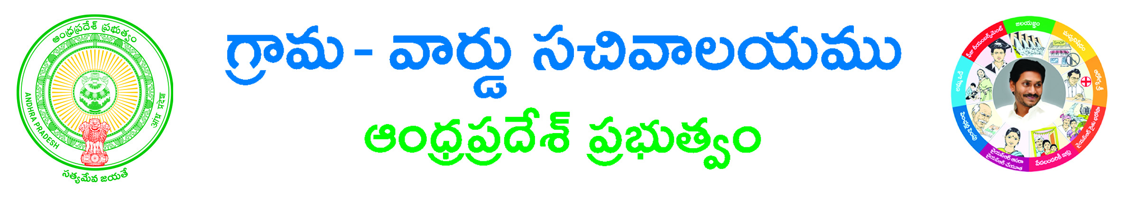
Conversion of White Card to Pink Card Conversion of White Card to Pink Card
SRI DURGA MALLESWARA SEVA TICKET BOOKING APPLICATION FORM
Seva Details
Seva Name*: _______________________________________________________________________
Seva Booking Date*: __________________
Devotee Details
Aadhar Card No: _________________________ Devotee Name*: _______________________________________
Proof Document: ____________________________Proof Document No: _________________________________
Gothram: _____________________________________ Nakshatram: ____________________________________
Gender*: Male Female Age: ________________ Mobile Number*: ____________________________
Email Id*: __________________________________________________
Devotee Address
House No*: __________________ Street Name/Location*: ____________________________________________
Country*: INDIA State*: _________________________ District*: ________________________________
Mandal*: _________________________ Village*: _____________________________ Pin Code: ______________
Applicant Details
Applicant Name*: ______________________________________________________________________________
Applicant Relation*: __________________________________ Seva Amount*: ____________________________
Documents List:
(NOTE: 1.Total size of Upload Document should not exceed 3 MB. 2. All Upload Documents should be in PDF Format Only)
1. Application Form*
2. Identity Proof *

Applicant’s Signature

