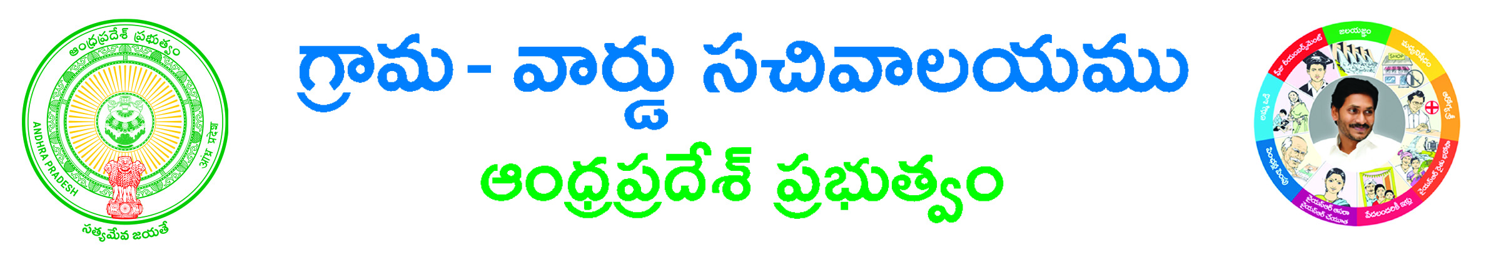

Permission For Event Bandhobust Application

Applicant Details (address for communication):-
Aadhaar Card No: ____________________Name of Applicant (in BLOCK letters)*: ___________________
Surname*: ___________________Father/Husband Name*: _______________ Gender *: ___________
Occupation *: ___________
State *: ___________________District*: ________________ Mandal*: __________________
Village / Ward *: ______________________ Door No: ________________________________
Locality/Land Mark: ______________ Pin Code: ___________ Mobile No*: ______________
Email ID: ______________
Informant Details:-
Informant Name*: _____________________________ Informant Relation*: ___________________
Delivery Type*: Manual Local Non-Local Mobile NO*:_____________________

Service Specific Details
Service required For *(Audio Release Function, Benefit show, Cinema success function, Commercial displays, Corporate anniversary function, Cultural/Fashion show, Customer Meet at Public places, Exhibitions/circus, Film shooting, Industrial Exhibition, Marriage function Hall/House Box Type Speakers, Mobile adt. for Autos, Mobile adt. for Vans, Orchestra for small programs, Public meetings, Rallies, Religious functions, TV shooting): __________________________
District/Commissionerate *: _____________ Police Station Jurisdiction Known *(Yes/NO):_______________
If Yes provide Police Station*: _______________, If No provide Nearest Landmark/ Area Description*:_______________
Remarks *:_______________
Event From Date (DD/MM/YYYY) *:_______________ Event To Date (DD/MM/YYYY)*:_______________

Document List:-
- ID Proof*
- Address Proof*
- If any other Documents.

Applicant’s Signature

