Bio-Metric Authentication User manual JVD Scheme
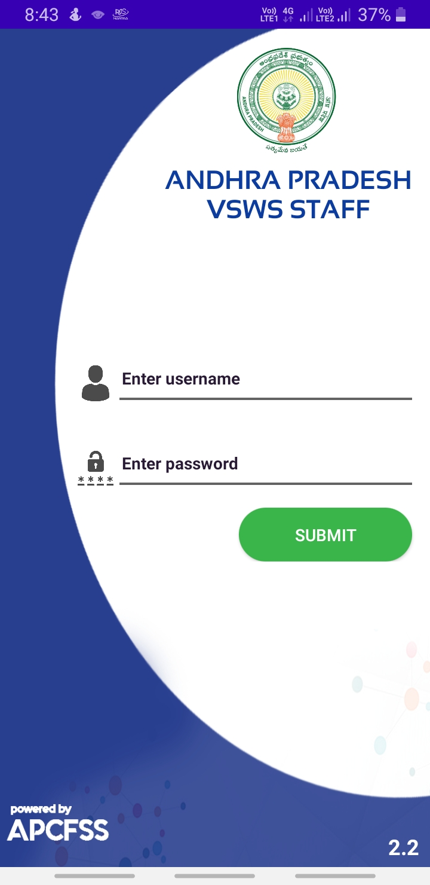
- Please open the application and login with Navasakam login Credentials
- After login, the below screen will be displayed
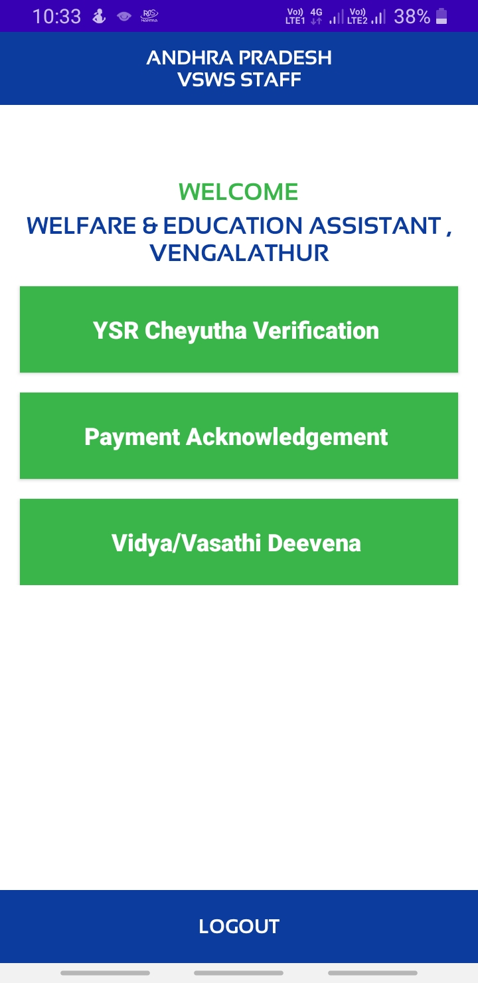
- Then select Vidya/Vasathi Deevena option.

- Volunteer Wise Pending list will be displayed as like below.
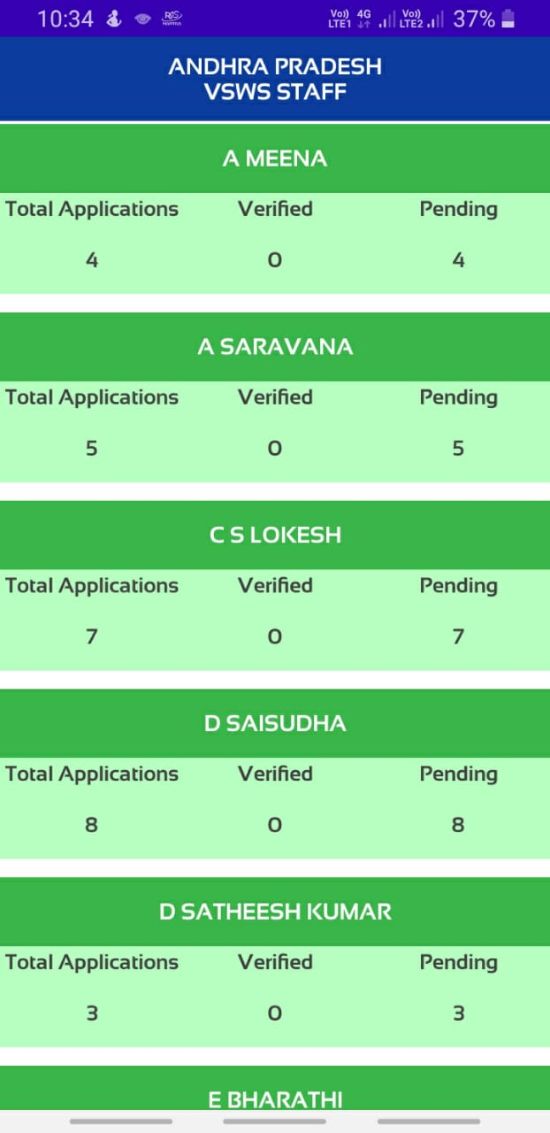
- Select volunteer Name having pending applications.
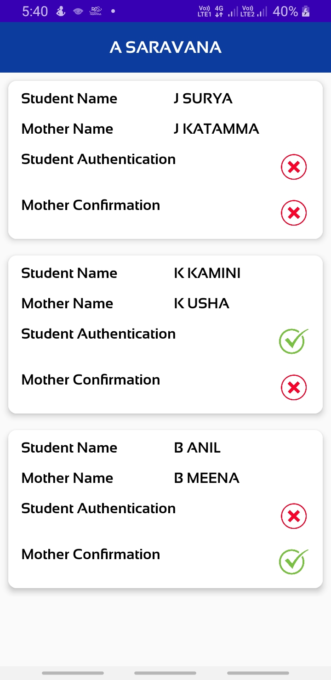
- After Selection of volunteer name, All JVD applications list will be displayed as like below.

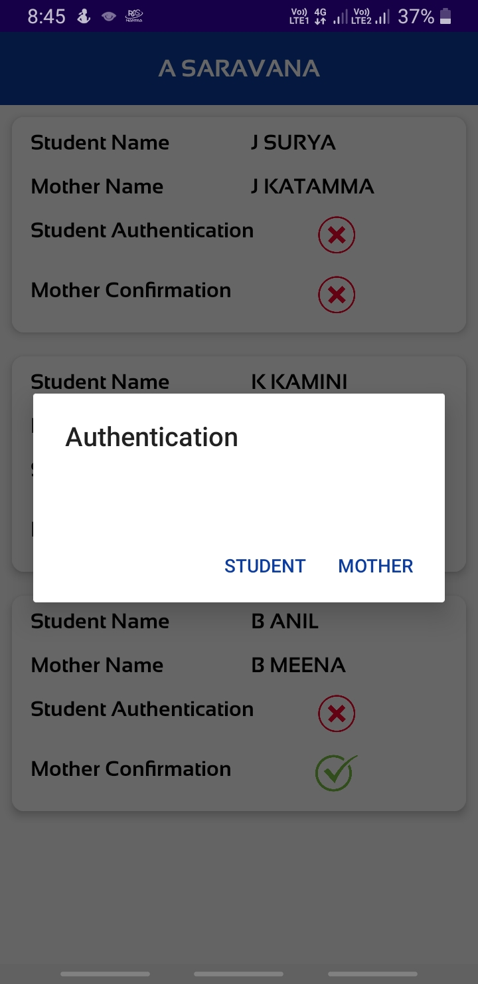
- Select Student/mother to take the Biometric Authentication.
- Above Authentication Pop up will come if student and mother both are not verified cases. Select student or mother.

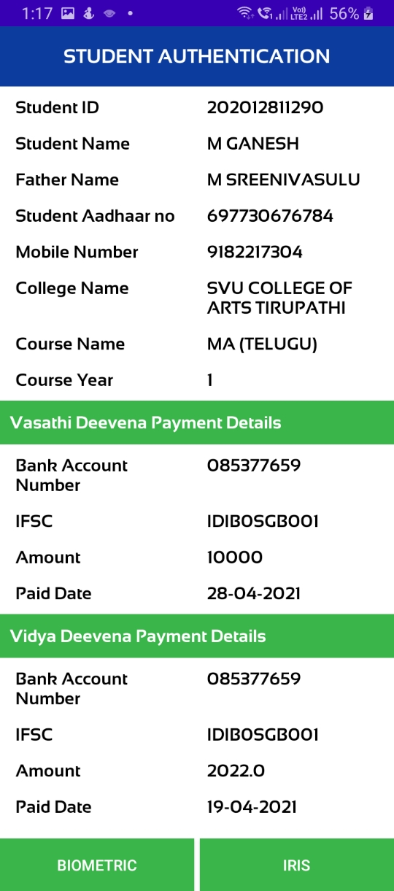
- If you select Student, below screen will be displayed Check the details and take student Biometric authentication.

- If student is already verified, when up click, it will take to mother screen without popup.

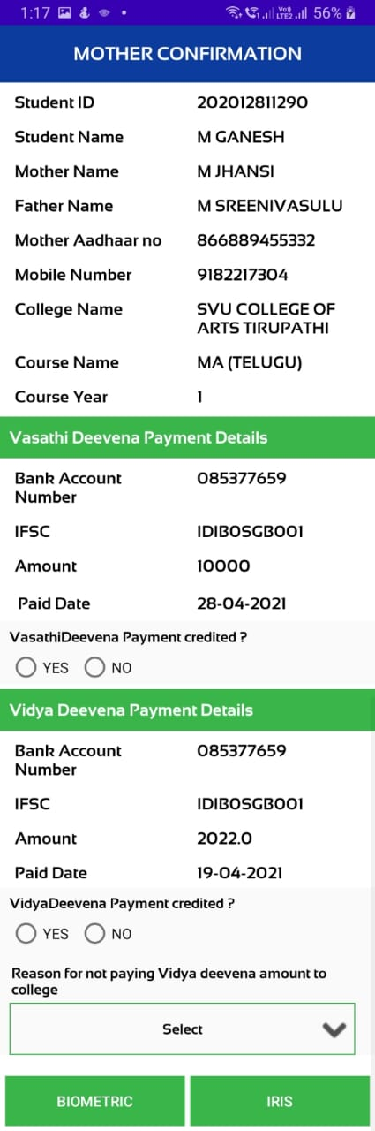
- If you select Mother, the below screen will be displayed.

- Please check whether the vasathi deevana credited in mother Bank account, if credited in account select yes, if not credited, select NO.

- Please check whether the Vidya deevana credited in mother Bank account, if credited in account select yes, if not select NO

- Select the Correct Reason for Not paying the 1st Quarter released amount to college (This option will appear only for those students who did not pay the first quarter fee to the college or even if paid, college failed to update it in the college login that the student paid)
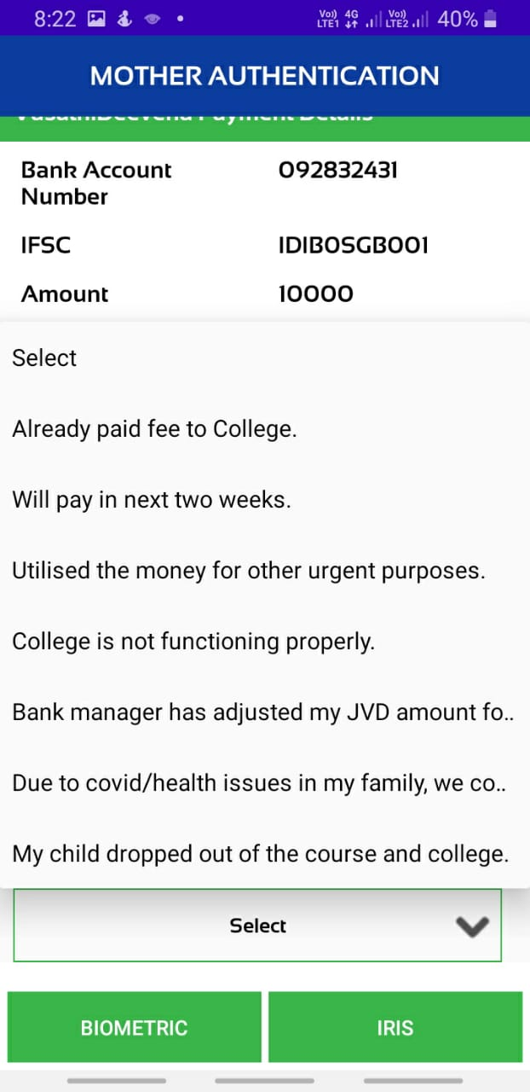

- Then, take bio metric authentication of the mother.

- Repeat the process till all students and mothers are verified.

- Once a student becomes eligible for sanction, his application will get automatically updated in the apk for bio metric authentication.

